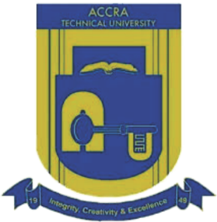**ACCRA TECHNICAL UNIVERSITY**

P.O. Box GP 561, Accra Ghana. <Tel:(+233)> 302 689276

Website: [www.atu.edu.gh](http://www.atu.edu.gh)

INDUSTRIAL LIAISON OFFICE

Our Ref: ATU/ILO/IAL/19 Date:

Your Ref:

…………………………………………………………………………………..

…………………………………………………………………………………..

…………………………………………………………………………………..

……………………………………………………………………………………

Dear Sir/ Madam,

**INDUSTRIAL ATTACHMENT (INTRODUCTROY LETTER)**

As part of the academic program, Higher National Diploma (HND) students are to be attached to industries of their chosen career. This is to enable them experience on the ground what is happening of their chose profession. It is part of their academic program, without which they cannot graduate.

In view of the above, the University would be grateful if you could accept

Mr./Mrs./Miss/…………………………………………………………………………………. a/an……………………………………………

Student to undertake his/her industrial training in your Organization.

We would like to bring to your notice that students under the attachment program have been insured under the Group Personal Accident Insurance Policy, which provides 24 hours protection to the insured.

Also, an online student’s E-logbook would be provided for your assessment of the student at the end of his/her training.

The program is to start on **MONDAY, 10TH JUNE, 2019** and end on **FRIDAY, 13TH SEPTEMBER, 2019**.

Thank you.

……………………………………………

**PROSPER AGUMEY**

**(INDUSTRIAL LIAISON DIRECTOR)**